SIMATS ENGINEERING
(Saveetha School of Engineering)
Department of Computer Science and Engineering
CO2 ASSESSMENT TOOL 2
Architecture Design Assignment
Case Study: MediVault — Healthcare Prescription Management Platform

Submitted By | Y. Rishitha Reddy
Register No. | 192424233
Department | Artificial Intelligence and Data Science
Subject | Software Engineering
Faculty | Dr. Latha R
College | SIMATS Engineering
Academic Year | 2024 – 2028

1. System Requirements Analysis
1.1 Problem Overview
MediVault is a healthcare prescription management platform designed to digitize the complete prescription lifecycle — from a doctor issuing a prescription, to a patient viewing and managing it, to a pharmacy fulfilling it. The system must securely connect patients, doctors, and pharmacies while maintaining strict compliance with healthcare data protection standards.
1.2 System Objectives
- Enable doctors to create, update, and digitally sign prescriptions.
- Allow patients to view, track, and receive reminders for their prescriptions and refills.
- Allow pharmacies to receive, verify, and fulfil prescriptions electronically.
- Maintain a secure, auditable, and tamper-evident record of all prescription activity.
- Integrate with external hospital, insurance, and pharmacy networks where required.
1.3 Functional Requirements
- User registration and role-based authentication for patients, doctors, and pharmacists.
- Prescription creation, digital signing, editing (with version history), and cancellation.
- Real-time prescription status tracking (issued, verified, dispensed).
- Automated notifications via SMS/email/app push for prescription updates and refill reminders.
- Search and retrieval of patient medical and prescription history.
- Pharmacy-side inventory check and fulfilment confirmation.
1.4 Non-Functional Requirements
- Security: End-to-end encryption of patient health data, in compliance with data protection norms (e.g., HIPAA-equivalent practices).
- Scalability: Support a growing number of concurrent users across hospitals and pharmacy chains.
- Availability: Near-continuous uptime, since prescription access can be safety-critical.
- Performance: Low-latency response for prescription retrieval and notification dispatch.
- Maintainability: Independent updates to individual services without full-system downtime.
- Reliability: Consistent and accurate data across all connected services, even during partial failures.
1.5 Key Quality Attributes Influencing Architecture
Quality Attribute | Why It Matters for MediVault
Scalability | Handles growth in patients, doctors, and pharmacy partners without redesign.
Security | Protects sensitive patient health records and prescription data.
Reliability | Ensures prescription data is never lost or corrupted.
Availability | Prescription access must remain available, including during peak load.
Performance | Fast issuance and retrieval of prescriptions, especially in urgent care.
Maintainability | Individual modules (e.g., notifications) can evolve independently.

2. Selected Software Architecture
2.1 Chosen Architectural Style: Layered Architecture combined with Microservices (Hybrid)
MediVault adopts a hybrid architecture: a layered structure (Client Layer, API Gateway/Security Layer, Service Layer, Data Layer, External Integration Layer) at the macro level, with the Service Layer internally implemented as independent microservices (Patient Records, Prescription Management, Pharmacy Integration, Notification, and Audit/Logging).
2.2 Justification
- Separation of concerns: The layered structure keeps presentation, security, business logic, and data storage cleanly separated, which simplifies reasoning about the system and onboarding new developers.
- Independent scalability: Microservices allow high-demand services (e.g., Notification Service during peak refill reminders) to scale independently of low-demand ones (e.g., Audit Service).
- Fault isolation: A failure in one microservice (e.g., Pharmacy Integration Service, if a third-party pharmacy API is down) does not bring down the entire platform.
- Security-critical layering: Placing Auth and TLS/WAF at a dedicated gateway layer ensures every request is authenticated and inspected before it reaches business logic — essential for healthcare data.
- Extensibility: New services (e.g., a future Insurance Claims Service) can be added without redesigning existing components.
A pure monolithic architecture was considered but rejected, since it would tightly couple patient records, prescriptions, and notifications, making independent scaling and safe incremental deployment difficult in a healthcare context where downtime and data errors carry high risk.

3. Software Architecture Diagram
The diagram below illustrates the complete system structure of MediVault, including all layers, components, databases, external systems, and communication mechanisms.
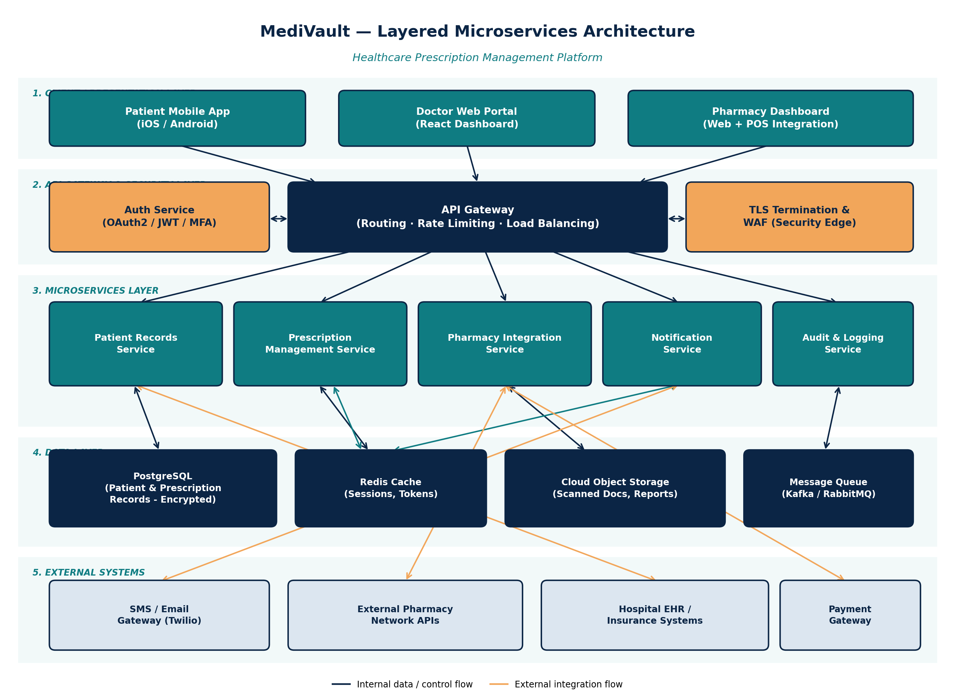
Figure 1: MediVault Layered Microservices Architecture

4. Components and Their Interactions
4.1 Component Responsibilities
Component | Responsibility
Client Apps (Patient/Doctor/Pharmacy) | Provide role-specific user interfaces for interacting with the system.
API Gateway | Single entry point; routes requests, applies rate limiting and load balancing.
Auth Service | Handles authentication (OAuth2/JWT) and multi-factor authentication.
TLS Termination & WAF | Encrypts traffic and filters malicious requests at the network edge.
Patient Records Service | Manages patient profiles and medical history.
Prescription Management Service | Handles prescription creation, updates, and status tracking.
Pharmacy Integration Service | Communicates with external pharmacy systems for fulfilment.
Notification Service | Sends SMS/email/app notifications for prescription events.
Audit & Logging Service | Records all critical actions for compliance and traceability.
PostgreSQL | Persists encrypted patient and prescription records.
Redis Cache | Stores sessions and tokens for fast authentication checks.
Cloud Object Storage | Stores scanned documents and generated reports.
Message Queue | Enables asynchronous, decoupled communication between services.

4.2 Communication Mechanisms
- Client-to-Gateway: Synchronous REST/HTTPS calls, secured via TLS.
- Gateway-to-Services: Synchronous internal REST calls for real-time requests (e.g., login, prescription lookup).
- Service-to-Service (async): Message queue (Kafka/RabbitMQ) used for events such as 'prescription issued' to trigger notification and pharmacy workflows without blocking the caller.
- Services-to-Data Layer: Direct, connection-pooled database access per service (database-per-service pattern for Patient Records and Prescription services).
- Services-to-External Systems: REST/SOAP API integrations with pharmacy networks, hospital EHRs, and payment gateways.
4.3 Overall Workflow
The figure below illustrates a representative end-to-end flow: a doctor issuing a prescription through to the patient receiving confirmation, with every step logged for compliance.
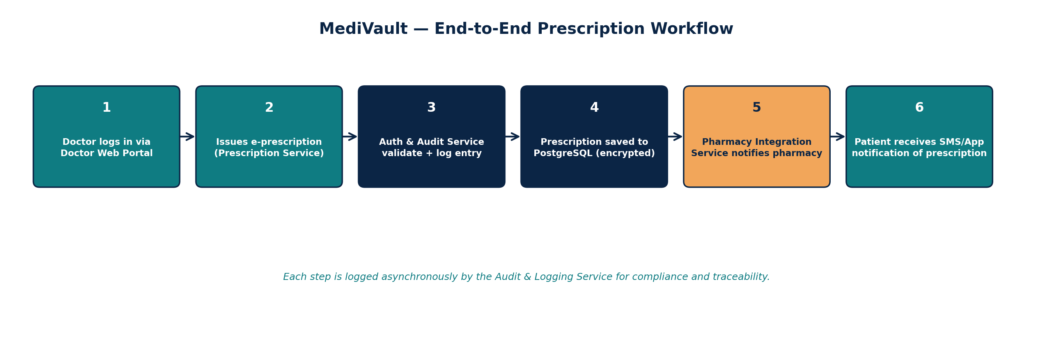
Figure 2: End-to-End Prescription Workflow

5. Discussion of Quality Attributes
Scalability
The microservices layer allows horizontal scaling of individual services — for example, spinning up more instances of the Notification Service during peak refill-reminder periods — without scaling the entire system.
Security
Dedicated Auth Service (OAuth2/JWT/MFA) and a TLS/WAF edge layer ensure encrypted transport and authenticated, filtered access. Encrypted storage protects data at rest.
Performance
Redis caching of sessions and tokens reduces repeated database hits, and asynchronous messaging keeps user-facing requests (like issuing a prescription) fast by deferring non-critical downstream work.
Reliability
The database-per-service pattern and message queue buffering mean a temporary outage in one service (e.g., Pharmacy Integration) does not cause data loss elsewhere — messages are retried once the service recovers.
Maintainability
Each microservice can be developed, tested, and deployed independently, reducing regression risk when updating a single feature such as notifications.
Availability
Load-balanced API Gateway and independently deployable services reduce single points of failure; the Audit Service logs issues to support fast diagnosis and recovery.

6. Justification of Architectural Decisions
6.1 Rationale
The hybrid layered-microservices approach was chosen because MediVault must simultaneously satisfy strict security requirements (healthcare data), variable load across different functions (notifications spike, audit logging is steady), and a need for independent evolution of features. A single layered monolith would meet the security and simplicity goals but would not scale specific hot-spots independently or isolate failures. Pure microservices without a layered security boundary would risk inconsistent authentication enforcement across services.
6.2 Trade-offs Considered
- Complexity vs. Flexibility: Microservices introduce operational complexity (service discovery, distributed monitoring) in exchange for independent scalability and deployment — considered acceptable given healthcare-scale growth expectations.
- Consistency vs. Availability: Asynchronous messaging favours availability and responsiveness over strict immediate consistency for non-critical events (e.g., notification delivery), while core prescription and patient data writes remain synchronous and strongly consistent.
- Cost vs. Isolation: Running separate databases per core service increases infrastructure cost but significantly improves fault isolation, which is prioritized in a healthcare context.
6.3 Support for Future Enhancements and Long-Term Maintainability
- New services (e.g., Insurance Claims, Telemedicine Integration) can be added behind the API Gateway without modifying existing services.
- The message queue provides a natural extension point for future event-driven features, such as AI-based drug-interaction alerts.
- Clear separation between layers allows the UI, business logic, and data storage to evolve on independent release cycles, supporting long-term maintainability as the platform grows across more hospitals and pharmacy networks.

